A macroscopic study on the muscles and tendons of forepaws in the Anatolian bobcat (Lynx lynx)
Abstract: This study was performed on the tendons and muscles of forepaws in two Anatolian bobcats (Lynx lynx). The research materials were donated by Republic of Turkey Ministry of the Forestry and Water Affairs Sivas Branch Manager. To achieve this objective, dissection and radiography techniques were applied to two dead materials. Digit I is radiographically rudimentary in the forepaw. The muscles and tendons of the forepaw in the bobcat are located in the cranial and caudal aspect of the antebrachium, the central manus and hypothenar region. The extensor muscles are situated on the cranial aspect of the antebrachium, while the flexor muscles are located on the caudal aspect of the antebrachium. The m. extensor carpi radialis in the extensor group has long and short portions; the m. extensor digitorum lateralis et communis give rise to tendons associated with fingers; the fascia covering the muscles emerges on the lateral and medial border of the m. extensor digitorum lateralis. The m. flexor digitorum superficialis et profundus lie on the caudal aspect of the antebrachium; the superficial digital flexor tendons give rise to the origin of the bellies of the m. flexor digitorum brevis; the m. flexor digitorum profundus form a stout tendon from which the mm. lumbricales originate on the palmar aspect of carpal joints; the tendon of the muscle perforates the tendon of the m. flexor digitorum superficialis. The mm. flexores digitorum profundi breves in the central manus group consist of the lateral and medial portions and insert on the palmar aspect of each proximal phalanx associated with the fingers. Other muscles in the group, adductores digitorum, end to those in the fingers.
Key words: Anatolian bobcat (Lynx lynx); forepaw; muscles; tendons; anatomy

Introduction
The bobcat (Lynx lynx), which is an endangered species and a medium-sized cat with a short tail, is a predatory carnivorous animal (1, 2). While the carnivorian hind limb primarily serves as a locomotor organ, the forelimb may also be involved in both capturing and subduing prey (3, 4, 5). In extant felids, forelimbs are particularly used to hold onto and position the struggling prey, though small prey specialists make less use of forelimbs in subduing prey. Therefore, the myology of the forelimbs of cats reflects ecomorphological history as well as adaptations to current behavior (6). The autopod of the forelimb is called the paw in drawings (7). The muscles and tendons of the forepaw may be grouped as located in cranial and caudal compartments of the antebrachium and, in the superficial, central and hypothenar compartments of the manus (8).
In terms of insertion, the muscles related to the forepaw in the cranial compartment of the antebrachium are m. extensor carpi radialis longus et brevis, m. extensor carpi ulnaris, m. extensor communis, m. extensor digitorum lateralis, m. extensor pollicis longus, and m. abductor pollicis longus (8). While the functions of m. extensor carpi radialis longus et brevis, and m. extensor carpi ulnaris are involved in the carpal joints, the others affect the digital joints. Forepaw muscles and tendons in the manus can be divided into hypothenar, superficial, and central compartments of the manus (8).
M. extensor carpi radialis longus originates from the lateral supracondylar ridge of the humerus in the felid (8, 9, 10). However, it has been described that the muscle arises from the lateral epicondyle of the humerus in the carnivores (11). After the muscle gives rise to a flat tendon in the distal third of the antebrachium, it passes through the common extensor retinaculum (8) and inserts onto the proximal shaft of the second metacarpal (8, 9, 10). The tendon also inserts into the third metacarpal in the carnivores (11). In ocelots, Julik et al. (8) stated that the m. extensor carpi radialis longus fuses proximally with the m. extensor carpi radialis brevis.
Like the m. extensor carpi radialis longus, the m. extensor carpi radialis brevis springs from the lateral supracondylar ridge of the humerus in the felis family. The muscle becomes a tendon in the distal quarter of the antebrachium that passes through the common extensor retinaculum before inserting into the third metacarpal bone (8, 9, 10, 11, 12).
The m. extensor carpi ulnaris originates from the epicondyle of the humerus in carnivores (8, 9, 10, 11, 12). In the cats, the muscle has a weak additional portion originating from the tendon in the trochlear notch of the ulna (11). The tendon of the muscle passes laterally over the carpus to end on the fifth metacarpal bone (8, 9, 10, 11, 12). In addition, the tendon inserts in both the pisiform bone and its ligament in ocelots (8), while another branch of the tendon radiates into the flexor retinaculum in the cat (11).
In the literature, there are different expressions about the origin of m. extensor digitorum lateralis in the carnivores. It was expressed that the origin of the muscle was the lateral supracondylar bridge of the humerus in the ocelot (8) and cats (10). In addition, the muscle stems from the superficial aspect of the m. supinator in the ocelot (Julik et al., 2012). Some researchers (10, 11) stated the origin as the lateral epicondyle of the humerus in the cats. The muscle that has three bellies (8, 9, 10, 11, 12) at the level carpal joint becomes a different number (three or four) of tendons in the carnivores. The tendons pass over the carpal joint and then fuse with the m. extensor digitorium communis III-V digits in the carnivores (8, 9, 10, 11, 12). In ocelots, the tendons extend to the carpal, metacarpophalangeal, and interphalangeal joints (8).
The m. extensor digitorum communis with a different number of bellies arises from different areas of the humerus, for example, the lateral supracondylar bridge and epicondyle, in the carnivores (8, 9, 10, 11). After the muscle bellies become tendons serving digits II-V at the distal third of the radius (9), the tendons pass through the shared retinaculum on the carpus joint in the carnivores (8, 9, 10, 11). They travel distally to contribute to the dorsomedial aspect of the extensor expansion in ocelots (8) and cats (10). Some researchers state their insertion area as the extensor process in the carnivores (9, 11).
The m. extensor digiti I (pollicis) longus is only found in carnivores (10) and originates from the distal third of the ulna, covering the tendon of the m. extensor digitorum lateralis, deep into the extensor tendons in the cats (8, 9, 10, 11, 12). Furthermore, the muscle with two bellies is called the m. extensor digiti I (pollicis) et II longus in the ocelot (8). In the cat family, its tendon gives rise to two slender branches ending at the first and second digits (8, 9, 10, 11, 12). A third branch that inserts into the third digit may exist in the cat family (8, 9).
The m. abductor digiti I (pollicis) longus that acts as the abductor for the first digit in the carnivores (10) arises from the lateral aspects of the ulna and radius and travels distally and medially to pass superficially into the tendon of the m. extensor carpi radialis in the carnivores. The muscle ends at the base of metacarpal I in the cat family (8, 9, 10, 11, 12). During this course, its tendon passes through its own retinaculum on the dorsomedial aspect of the carpus, deep into the common extensor retinaculum in the ocelot (8).
The muscles of the cranial compartment of the antebrachium that act as forepaw joints comprise the m. flexor carpi radialis et ulnaris, m. flexor digitorum superficialis et profundus, and m. palmaris longus (8, 9, 10, 11, 12).
The m. flexor carpi radialis arises from the medial epicondyle of the humerus in carnivores (8, 9, 10, 11). Its tendon passes over the flexor side of the carpus to end at the palmar aspect of the third and second metacarpal bone in carnivores (8, 9, 10, 11). In the ocelots, its tendon passes through its own retinaculum, deep into and medial to the retinaculum of the m. flexor digitorum profundus at the level of the carpal joints (8).
The m. flexor carpi ulnaris consists of the ulnar and humeral heads. The caput ulnare arises from the olecranon process of the ulna, while the caput humerale originates from the medial epicondyle of the humerus (8, 9, 10, 11, 12). In the right limb of the ocelot, Julik et al. (8) stated that the caput ulnare consists of the distal and proximal bellies. In carnivores (9, 10, 11), both heads end with a common tendon that is inserted into the accessory carpal bone, while in ocelots (8), both portions pass through a shared flexor retinaculum on the palmar aspect of the carpus to end at the pisiform carpal bone. Furthermore, in ocelots, the ulnar head is fused with the caput humerale laterale of the m. flexor digitorum profundus in the distal third of the antebrachium (8).
The m. flexor digitorum superficialis stems from the medial epicondyle of the humerus in carnivores (9, 10, 11, 12), while the muscle that has three bellies serving digits II–IV emerges from the superficial aspect of the m. flexor digitorum profundus in ocelots (8). In the cat family, the tendon of the muscle that becomes tendinous at the level of the carpus splits into five portions serving digits I–V in the proximal third of the metacarpal bone (9, 10, 11). On the other hand, in ocelots, at the level of the metacarpophalangeal joints (8), the tendon serving digit III is fused with the m. palmaris longus, while the tendon serving digit IV is fused with the m. flexor digitorum brevis. Only the tendon serving digit II remains independent. In the cat family, all of the tendons pass deep into the proximal annular ligament of the digit they serve and divide to allow for the passage called the manica flexoria of the m. flexor digitorum profundus (8, 9, 10, 11, 12). Each of the tendons end at the proximal border of the middle phalanx of the first to fifth digits in the cats (9, 10, 11) and the second to fourth digits in the ocelot (8). Hubbard et al. (2009) described that the tendons of the third and fourth digits give off a single metacarpal pad suspensory ligament, deep in the metacarpal pad in cats and clouded leopards.
The m. flexor digitorum profundus is composed of three separable heads in carnivores (9, 10, 11, 12) or five heads in the ocelot (Julik et al., 2012). In carnivores (9, 10, 11), the muscle heads are called caput humerale, radiale, and ulnare, while in the ocelot (8), the heads are named capita humerale laterale, mediale and profundus, capita ulnare, and capita radiale. The caput humerale that originates from the medial epicondyle of the humerus is composed of three distinguishable bellies and the strongest head in the cat (9, 10, 11). In ocelots (8), the caput humerale mediale, laterale, and ulnare separately arise from the medial epicondyle of the humerus. The caput ulnare originates from the caudal border of the ulna and olecranon in the cats (9, 10, 11, 12), while it arises from the proximal two-thirds of the ulna in the ocelot (8). In the cats, the caput radiale springs from the proximal caudomedial border of the radius (9, 10, 11). On the other hand, the capita radiale et ulnare originates from the caudal aspects of the ulnar shaft, the caudal and caudomedial aspects of the radial shafts, and the interosseous membrane in ocelots (8). All the heads of the muscle are joined together to form the strongest tendon just proximal to the carpus in the cat family (8, 9, 10, 12). The conjoined tendon courses through a shared flexor retinaculum and continues distally to serve all five digits. In the proximal metacarpal region, when it detaches a thin tendon to the first digit, the main tendon divides into four powerful limbs for digits II–V in the cat family. They are enveloped by the tube-like cuff of the m. flexor digitorum superficialis, called the manica flexoria, under the metacarpal pad in the cats. After the tendons initially pass through the proximal annular ligament and then the distal annular ligament at the proximal phalanx level of the digits served, they insert into the palmar aspects of the distal phalanx digits (8, 9, 10, 11, 13).
The m. palmaris brevis located in the superficial compartment of the manus originates from the lateral side of the flexor retinaculum. It then run transversely to insert on the metacarpal paw pad in the ocelot (8).
The m. flexor digitorum brevis that is shaped like a cone in cats (11) is composed of two superficial bellies and one deep belly in the ocelot (8). The muscle arises from the tendon sheet of the superficial flexor above the carpus to fuse with the tendons of the superficial flexor of digits IV–V or III–V in the cat (11). On the other hand, in the ocelot, the lateral superficial belly of the muscle arises from the tendon of the m. palmaris longus on the distal side of the antebrachium. The medial superficial belly springs from the deep and caudal aspect of the flexor retinaculum, while the deep belly originates from the deep lateral aspect of the tendon of the m. palmaris longus in the distal quarter of the antebrachium. Two superficial bellies fuse and give rise to a shared tendon to digit V, while the deep belly gives rise to a tendon to digit IV (8).
The m. abductor digiti V belonging to the hypothenar compartment of the manus originates from the pisiform, the ligaments articulating the pisiformis with the fourth and fifth metacarpal bones, the m. flexor carpi ulnaris’s insertion tendon in the ocelot (8), while the muscle arises from the accessory carpal bone in cats (11). In both cats and ocelots, the muscle inserts into the base of the phalanx proximalis of digit V (8, 11).
The muscles of the central compartment of the manus are mm. lumbricales, mm. adductors digitorum, and mm. flexores profundi breves. Mm. lumbricales are composed of four distinct bellies serving digits II–V. The bellies originate from the common tendon of the m. flexor digitorum profundus and end at the base of the phalanx proximalis of their respective digits (8, 11).
The mm. adductores digitorum serving digits I, II, and V arises from the transverse carpal ligament, and each muscle inserts onto the base of the phalanx proximalis of its respective digits in the cat family (8, 11).
The mm. flexores profundi breves, except digit I, consist of a medial and lateral belly serving each digit; on the first digit, only a medial belly is present. The bellies of the muscle stem from the transverse carpal ligaments (8).
Because anatomical descriptions concerning the muscles and tendons of the paw in the Anatolian bobcat have not been found, in the present study, we aimed to describe a detailed macroanatomy of the muscles and tendons of the paw in the Anatolian bobcat.

Materials and Methods
The study was conducted on two female Anatolian bobcats (cadaver I was 6.9 kg and cadaver II was 7.6 kg in weight, respectively). The animals were obtained from Republic of Turkey Ministry of the Forestry and Water Affairs Sivas Branch Manager. After the animals died of natural causes (14), they were immediately transported to Department of Anatomy of Faculty of Veterinary Medicine at Cumhuriyet University. The animals were fixed with 10% formalin via the carotid common artery to prepare the cadavers. Then, the forelimbs of the cadavers were dissected and photographed with a Canon 50D camera. Radiographic images of manus were taken in dorso-palmar position using PCMAX-100H® (led: input voltage: 3.3 VDC, 2A: Korea). The terminology used in the manuscript is in accordance with the prevailing veterinary nomenclature (15).

Results
The forepaws are 132.84 mm long and 42.33 mm wide on average and consist of the first, second, third, fourth, and fifth fingers (Fig. 2F). The first finger, called the dewclaw, is rudimental and composed of the first metacarpal, the proximal and distal phalanx bones (Fig. 2F/I).
The m. brachioradialis located on the cranial border of the forearm and beneath the skin originates from the caudal aspect of the distal humeral shaft as broad and fan-shaped in the two cadavers (Fig. 1A/2). The muscle that gets thinner at the cranial aspect of the elbow joint travels distally on the cranial aspect of the antebrachium. After it passes over the m. abductor digiti I longus at the level of the distal quarter of the antebrachium, the m. brachioradialis ends on the dorsal aspect of the radial carpal bone.
The m. extensor carpi radial longus that is fused with the m. extensor carpi radial brevis originates from the lateral supracondylar ridge of the distal humerus in both cadavers (Fig. 1A/4rl). In the two cadavers, both muscles distally continue between the m. brachioradialis and the m. extensor digitorum communis on craniolateral aspect of the forearm. While the m. extensor carpi radialis brevis (Fig. 1A/4rb) gives rise to a thin tendon at the mid-antebrachium, the m. extensor carpi radialis longus distally extends, then enters deep into the m. abductor digiti I longus at the distal quarter of the antebrachium and divides into two tendons. The tendons pass under a common extensor retinaculum on the dorsal carpus. While the intertion of the thin tendon is at the dorsal aspect of the base of the second metacarpal bone, the stout tendon inserts onto the dorsomedial aspects of the base of the third metacarpal bone in the two cadavers.
The m. extensor carpi ulnaris located at the caudolateral positon in the forearm and enclosed fascia, which emerges from the caudal border of the m. extensor digitorum lateralis, originates from the lateral epicondyle of the humerus in the two cadavers (Fig. 1A/6). The muscle that runs along the caudal border of the lateral digit gives rise to a tendon (Fig. 1A/6t) in the distal quarter of the antebrachium that passes through the retinaculum extensorium in the two cadavers (Fig. 1A/RE). The tendon inserts into the dorsal aspect of the basis of the fourth metacarpal bone.
The m. extensor digitorum lateralis situated in the lateral position in the forearm stems from the lateral aspect of the olecranon and from the lateral supracondylar bridge of the distal humerus in the two cadavers (Fig. 1A/5). The muscle travels distally and then gives rise to a tendon (Fig. 1A/5t) in the mid-antebrachium that passes through the extensor retinaculum on the dorsolateral aspect of the manus. In its course, the fasciae (Fig. 1A/Fc) originate from both the cranial and the caudal border of the muscle. After the course under the retinaculum, the tendon divides into three branches on the dorsal aspect of the fourth and third metacarpal bones in both cadavers (Fig. 1A/5T IV–III). The medial branch runs in the distomedial direction on the dorsal aspect of the metacarpal bone and under the common digital extensor tendon to reach the dorsal aspect of the fetlock joint. The branch inserts on the dorsal aspect of the middle phalanx of the third finger in the two cadavers (Fig. 1A/5tııı). The middle branch travels in the distomedial direction to arrive at the lateral aspect of the fetlock joint in the fourth finger. Then, the branch inserts on the middle phalanx in the fourth finger (Fig. 1A/5ıv). The lateral branch, after origin, continues along the caudal border of the fifth metacarpal bone to reach the dorsal aspect of the fetlock joint in the fifth finger. The branch ends at the middle phalanx of the fifth finger in both cadavers.
The m. extensor digitorum communis is composed of three bellies originating from the humerus (capita humerale; Fig. 1A/3ch), the ulna (capita ulnare; Fig. 1A/3u), and the olecranon (capita olecranon) in the two cadavers. The capita olecranon that is the weakest belly emerges from the lateral aspect of the olecranon and then passes under its origin at the lateral digital extensor muscle in both cadavers. The muscle belly fuses with the capita humerale in the proximal antebrachium. The humeral head arises from the lateral supracondylar bridge and epicondylus of the humerus to reach the cranial aspect of the elbow joint in the two cadavers (Fig. 1A/3ch). The belly that is covered by the fascia originates from the m. extensor digitorum lateralis in the proximal antebrachium and travels distally on the cranial aspect in the proximal antebrachium. The caudal portion of the belly becomes a tendon in the mid-antebrachium, while the cranial portion of the belly becomes a tendon in the distal radius (Fig. 1A/3cht). The capita ulnare arises from the lateral aspect of the ulna and then runs distally between the m. extensor digitorum lateralis and m. extensor carpi radialis longus in the lateral aspect in the antebrachium to turn into a tendon in the proximal antebrachium (Fig. 1A/cut). The tendons of the bellies that are covered by the fascia in the lateral aspect of the forearm, the latter extensor retinaculum in the dorsal aspect of the carpal joint, continue distally to reach the base of the third metacarpal bone in each cadaver (Fig. 1A/3hııı). The common tendon divides into four tendons that serve each digit (II–V) at the base of the third metacarpal bone. Each tendon branch runs distally along the dorsal aspect of the metacarpal bone to end at the extensor process of the distal phalanx associated with digits II–V (Fig. 1A/3chıı-ııı-ıv-v). During this course, each tendon makes the expansion on the dorsal aspect of both the fetlock joint and the proximal interdigital joint associated with the digits.

The m. abductor pollicis originates from the shaft of the radius and ulna in the distal half of the antebrachium in both cadavers. It crosses obliquely in the craniodistal position in the distal quarter of the antebrachium to arrive at the extensor retinaculum (Fig. 1A/8). The muscle that covers the extensor retinaculum in the dorsal aspect of the carpal joint passes between the tendons of the m. extensor digitorum communis and m. extensor carpi radialis longus to become a tendon in the two cadavers (Fig. 1A/8). Its tendon inserts onto the dorsal aspect of the first carpal bone and the base of the first metacarpal bone.
The m. flexor carpi ulnaris composed of two bellies (capita humerale (Fig. 1B/11ch) and ulnare (Fig. 1B/11cu) is located on the caudal aspect of the antebrachium. The capita ulnare that is thinner than the capita humerale springs from the caudomedial aspect of the olecranon and travels along the caudal border of the capita humerale. The muscle gets thinner and thinner and becomes a thin tendon situated caudally to the capita humerale in the mid-antebrachium (Fig1B/11cu). The tendon continues distally to join with the tendon of the capita humerale deep into the carpal pad in the two cadavers (Fig. 1B/11cu). The strongest capita humerale originates from the medial epicondyle of the humerus between the origin of the capita ulnare and the m. flexor digitorum superficialis and becomes the strongest tendon (Fig. 1B/11cht) in the distal quarter of the antebrachium in the two cadavers. The tendon fused with the tendon of another head passes through the retinaculum on the lateral side of the palmar carpus and ends at the accessory carpal bone in both cadavers (Fig. 1B/11t).
The m. flexor carpi radialis (Fig. 1B/13) situated on the caudal aspect of the antebrachium, just under the skin and fascia, arises from the medial epicondyle of the humerus. The muscle covered by fascia continues distally in the groove located cranially to the capita humerale of the m. flexor digitorum profundus to give rise to a tendon on the distal third of the antebrachium in the two cadavers. Then, the tendon passes through a shared retinaculum on the medial side of the palmar manus to insert on the base of the third metacarpal bone in both cadavers (Fig. 1B/13t).
The m. flexor digitorum superficialis covered by the fascia originates from the caudal border of the m. flexor carpi radialis and arises from the medial epicondyle of the humerus (Fig. 1B/7). The muscle located under the skin travels distally on the caudal aspect of the forearm and becomes the strongest tendon in the mid-antebrachium in the two cadavers (Fig. 1B/7t). In the distal quarter of the antebrachium, this tendon gives rise to a thin branch serving the carpal pad and the superficial bellies of the m. flexor digitorum brevis, then passes through the common retinaculum in the palmar aspect of the manus to divide into five branches serving each associated digit in the two cadavers (Fig. 1B/7tı-v). A slender branch serving the first digit originates from the tendon of the m. flexor digitorum superficialis and inserts on the base of the proximal phalanx in the first digit (Fig. 1B/11tı). Another four branches travelling under the metacarpal pad in the palmar aspect of the forepaw end at the palmar aspect at the base of the phalanx secunda associated with the digits. Each branch is perforated by the branch of the profound digital flexor tendon at the level of the insertion.
The superficial bellies of the m. flexor digitorum brevis originate from the tendon of the m. flexor digitorum superficialis in the distal quarter of the antebrachium, while the profound bellies arise from the retinaculum flexorum in the palmar aspect of the carpal joint (Fig. 1B/12). The superficial bellies with the tendon of the m. flexor digitorum superficialis passes under the retinaculum flexorum and turns into a tendon deep in the metacarpal pad. The tendon lies distally under the metacarpal pad to the palmar aspect of the metacarpal bones IV–V (Fig. 1B/12).
The m. flexor digitorum profundus arises from the distinct area as five heads in the two cadavers (Fig. 1C/14). The heads of the m. flexor digitorum profundus lie distally on the mediocaudal aspect of the antebrachium and insert deep into the m. flexor digitorum superficialis and become a stout tendon (Fig. 1C/14*) (the common tendon of the heads of m. flexor digitorum profundus) under the metacarpal pad. The belly that originates from the medial border in the proximal third of the radius and called the capita radiale (Fig. 1C/14cr) travels distally and becomes a tendon (Fig. 1C/14rdt) in the distal quarter of the antebrachium. The tendon passes through the flexor retinaculum in the palmar aspect of the carpal joint to contribute to the tendon of the m. flexor digitorum profundus under the metacarpal pad. The capita ulnare (Fig. 1C/14cu) arises from the caudal aspect of the proximal ulna, and the muscle lies distally on the caudal aspect of the interosseous membrane. The muscle’s superficial portion becomes a tendon that contributes to the common tendon of the m. flexor digitorum profundus at the level of the mid-antebrachium, while the muscle’s profound portion directly inserts on the common tendon of both the right and left paws in the two cadavers. The capita humerale mediale (Fig. 1C/14chm) that originates from the medial epicondyle by a wide tendon (Fig. 1C/14chmt) runs distally on the caudal aspect of the antebrachium, deeps into the m. flexor digitorum superficialis, to become a tendon in the distal quarter of the antebrachium. Then, the tendon passes under the flexor retinaculum in the palmar aspect of the carpal joint to contribute to the common tendon of the m. flexor digitorum profundus in both limbs (Fig. 1C/14chmt). The capita humerale laterale (Fig. 1C/14cml) that originates from the medial epicondyle of the humerus in the two heads turns into a tendon (Fig. 1C/14chlt) in the mid-antebrachium, deep into the m. flexor digitorum superficialis in the two cadavers (Fig. 1C/14chlt). The capita humerale profundus (Fig. 1C/14chp) situated in the deepest originates from the medial epicondyle of the humerus and then becomes a tendon (Fig. 1C/14chpt) in the distal third of the antebrachium. After passing under the flexor retinaculum, the tendon ends to contribute to the common tendon of the m. flexor digitorum profundus in both limbs (Fig. 1C/14*). The common tendon of the m. flexor digitorum profundus lies deep in the metacarpal pad in the carpal tunnel and firstly gives rise to slender a tendon in the first finger in the mid-metacarpal bone (Fig. 1C/14tı). The common tendon breaks off into four branches (II, III, IV, V) (Fig. 1C/14ıı-v) to each finger deep in the metacarpal pad in the two cadavers. Each tendon branch lies distally in the palmar aspect of the metacarpal bone associated with the finger to initially pass through the proximal annular ligament in the palmar aspect of the fetlock (Fig. 1C/pal); shortly after, it passes through the superficial digital flexor tendon, and finally, the distal annular ligament (Fig. 1C/dal) in the mid-proximal phalanx, ending at the muscular tubercle of the distal phalanx (Fig. 1C/14tı-v).
The m. abductor digiti V that arises from the palmar aspect of the accessory carpal bone and has a triangle shape turns into a tendon in the mid-first metacarpal bone in the two cadavers (Fig. 1B/9). Then, the tendon lies distally on the lateral aspect of the first finger to insert onto the palmar aspect of the proximal phalanx of the first finger (Fig. 1B/9t).
The mm. lumbricales situated on the palmar aspect of the profound digital flexor tendon and under the superficial digital flexor tendon arise from the profound digital flexor tendon as four bellies at the metacarpal pad (Fig. 1C/15). Then, the bellies descend distally deep into the metacarpal pad to become a tendon in the palmar aspect of the fetlock joint. Each tendon ends at the palmar aspect of the bases of metacarpal bones II–IV.
The mm. flexores digitorum profundi breves composed of five distinct muscles originate from the distal row of carpal bones and lie distally on the palmar aspect of the metacarpal bone in each finger to end at the palmar aspect of the base of the proximal phalanx (Fig. 2E/10LB-MB). Each muscle consists of lateral and medial bellies. The weakest of the mm. flexores digitorum profundi breves is the m. flexor digiti I brevis (Fig. 2E/10LB-MB).
The mm. adductores originate from the distal row of carpal bones and run distally firstly to the palmar aspect and finally to the interdigital aspect of each metacarpal bone associated with the finger to insert onto the interdigital aspect of the proximal phalanx in each finger (Fig. 2E/16).
Discussion
The muscles and their tendons acting on the digital and carpal joints in the forelimb’s paw, as described by Julik et al. (8), are sorted as located in the cranial and caudal compartments of the antebrachium and, the superficial, central and hypothenar compartments of the manus. As has been described in previous literature (8, 9, 10, 11, 12), it was observed that extensor group muscles are located in the cranial aspect of the antebrachium. In this study, the origin of the radial extensor muscles of the manus is similar to that in carnivores, as depicted in the literature (8, 9, 10, 11), but the insertion tendon of the long portion of the muscle ending at the second metacarpal bone is different from what was described in the literature on carnivores (8, 9, 10, 11, 12). It was previously described that the origin of the m. extensor digitorum lateralis was the lateral supracondylar bridge of the humerus and the superficial aspect of the supinator muscle in the ocelot (8). However, in the present study, the origin of the muscle has been observed to be the lateral supracondylar bridge of the humerus and the lateral aspect of the olecranon. The finding that the fascia originate from both the cranial and caudal border of the muscle was firstly obtained in the present study. As was described in the ocelot (8), it has been seen that the muscles turn into a stout tendon in the mid-antebrachium and pass under the extensor retinaculum in the dorsal aspect of the carpal joints. However, it has been revealed that the tendon of the muscle divides into three branches, and each branch inserts onto the dorsal aspect of the second phalanx of the third, fourth, and fifth fingers in the Anatolian bobcat. Although it has been reported that the m. extensor digitorum communis arises from a different area of the humerus in carnivores (8, 9, 10, 11, 12), in the present research, it was found that the muscle originates from the ulna, olecranon, and the lateral supracondylar bridge as three heads. In addition, in this study, it was observed that the ulnar head turns into a tendon in the proximal antebrachium. While becoming a tendon of the cranial portion of the humeral head is the distal radius, those of the caudal portion of the humeral head is in the mid-antebrachium in the Anatolian bobcat. As was described in the ocelot (8), the tendon of the muscle passes under the common extensor retinaculum and divides into four branches for each finger (II–V) in the research. It has been seen that each branch enlarges in the dorsal aspect of fetlock and the proximal interdigital joint and ends at the extensor process of the distal phalanx of the associated finger.
In this study, as described in the literature (8, 9, 10, 11, 12), it has been seen that the flexor muscle group of the forearm situated at the caudal aspect of the antebrachium and their tendons act on the forepaw in the Anatolian bobcat. In this study, it was found that the m. flexor carpi ulnaris arises from both the olecranon and the medial epicondyle of the humerus as two heads, as depicted in the research (8, 9, 10, 11). In the Anatolian bobcat, it has been seen that the region in which the caput ulnare turns into a tendon is in the mid-antebrachium, while for the caput humerale, it is in the distal quarter of the antebrachium. In the study, the findings of the muscle insertion are similar to those described in the literature on carnivores (8, 9, 10, 11). The origin and insertion of the m. flexor carpi radialis in the Anatolian bobcat are similar to what has been reported in the literature. However, in this study, it was observed that the muscle turns into tendon in the distal third of the antebrachium. The findings about the origin and location of the m. flexor digitorum superficialis obtained in this study are similar to the data given in the literature about carnivores (8, 9, 10, 11). However, Julik et al. (8) called the muscle the palmaris longus in the ocelot. As described by many authors (8, 9, 10, 11), it has been found that the tendon of the muscle divides into five branches in the palmar aspect of the carpal joints in the Anatolian bobcat. However, in this study, it was observed that the tendon of the muscle gives rise to the superficial portion of the m. flexor digitorum brevis and a thin tendon serving the carpal pad. In addition, each tendon associated with the fingers is perforated by a deep digital flexor tendon at the level of the palmar aspect of the base of the phalanx media in the Anatolian bobcat. As previously depicted by Julik et al. (8), the m. flexor digitorum profundus in five separate heads arises from the distal humerus, the proximal part of the ulna, and the radius in the Anatolian bobcat. In this study, as in the investigation by Julik et al. (8) in the ocelot, the heads have been named as the radial, ulnar and deep, medial, and lateral humeral heads in the Anatolian bobcat. In this study, it was observed that a stout tendon forms to unite all heads in the palmar aspect of the antebrachium. The tendon gives rise not only to the tendon branch for the muscular tubercle of the phalanx distalis, but also to the mm. lumbricalis in each finger, except the first finger, in the Anatolian bobcat. Furthermore, in this study, it was found that each tendon associated with each finger passes through both the superficial digital flexor tendon and proximal and distal annular ligament related to each finger. The findings about the mm. lumbricalis and its tendons obtained from this study are similar to the data expressed by Julik et al. (8) in ocelots.
The evidence related to the origin and insertion of the central muscles of the manus observed in this study is similar to the outcomes described by Julik et al. (8) for the ocelot. However, in the present study, it was seen that each mm. flexores digitorum profundi breves consists of lateral and medial bellies.
In conclusion, our investigation showed that the fasciae, muscles, and tendons of the forepaw are well-developed in the Anatolian bobcat. In particular, the m. flexor digitorum pprofundus and its stout tendon both work as flexor functions of fingers and give rise the mm. lumbricales. In addition, the flexor muscles in the palmar aspect of the antebrachium, its tendons, and the muscles of the central manus play a role not only in the organs of the locomotor system, but also in subduing struggling prey for the Anatolian bobcat. The muscle and tendon structures of the forepaw may be advantageous for the hunting and survival of the Anatolian bobcat.
Acknowledgment
This research has not received any special grants. Permission was obtained from the Cumhuriyet University Animal Experiments Local Ethics Board for the study.
Authors declare that there is no conflict of interests regarding the publication of this article.

References
1. Özgel O, Aykut M. Macroanatomical investigation on ossa membri pelvini of Anatolian bobcat Lynx. Pakistan J Zool 2015; 47: 1492–1494.
2. Arı HH, Kuru N, Uslu S, Özdemir Ö. Morphological and histological study on the foot pads of the Anatolian bobcats (Lynx lynx), Anat Rec 2018; 301: 932-938.
3. Iwanuik AN, Pellis SM. Whishaw IQ. The relationship between forelims morphology and behaviour in North American carnivores (carnivore), Can J Zool 1999; 77: 1064-1074.
4. Andersson K. Elbow-joint morphology as a guide to forearms function and foraging behaviour in mammalian carnivores. Zool J Linn Soc-Lond 2004; 142: 91-104.
5. Meachen-Samuels J, Van Valkerburgh B. Forelimb indicator of the prey-size prefence in felidae. J Morpho, 2009; 270: 729-744.
6. Oliveira TGD. Leopardus wiedii. Mammal species 1998; 579: 1-6.
7. Tanaka M. Fins into Limbs: Autopod acquisition and anterior elements reduction by modifying gene networks involving 5’Hox, Gli3, and Shh, Dev Biol 2016; 413: 1-17.
8. Julik E, Zack S, Adrian B, Mordia S, Parsa A, Meifawn P, Starbuck A, Fishes RA. Functional anatomy of the forelimbs muscles of the ocelot (Leopardus pardalis). J Mamm Evol 2012; 19: 227-304.
9. Getty R. Sisson and Grossman’s the anatomy of the domestic animals. WB Saunders Company, Philadelphia London Toronto. 1975.
10. Konig HE, Liebich HG. Veterinary anatomy. Malatya, Turkiye: Medipress Mat. ve Yay. 2015.
11. Nickel R, Shummer A, Seiferle E, Frewein J, Wilkens H, Wille KH. The locomotor system of the domestic animals. In Nickel, R., Schummer, A., Seiferle, E. The Anatomy of the Domestic Animals 1986; Vol 1, Verlag Paul Parey Berlin Hamburg.
12. Dyce KM, Sack WO, Wensing CJG. Textbook of veterinary anatomy. Philadelphia, PA: Saunders, 1996.
13. Hubbard C, Naples V, Ross E, Carlon B. Comparative analysis of paw pad structure in the Clouded leopard (Neofelis nebulosa) and domestic cat (Felis catus). Anat Rec 2009; 292: 1213-1228.
14. Cumhuriyet University was delivered dead Lynx in Sivas in order to make the post-mortem examination. 2016. www.sivas.ormansu.gov.tr/sivas/Anasayfa/resimliHaber.
15. Nomina Anatomica Veterinaria. Prepared by the International Committes on Veterinary Gross Anatomical Nomenclature and Authorized by the General Assembly of the World Association of Veterinary Anatomists, The Editorial Committee Hannover, Sapporo, Japan.2012; 13.

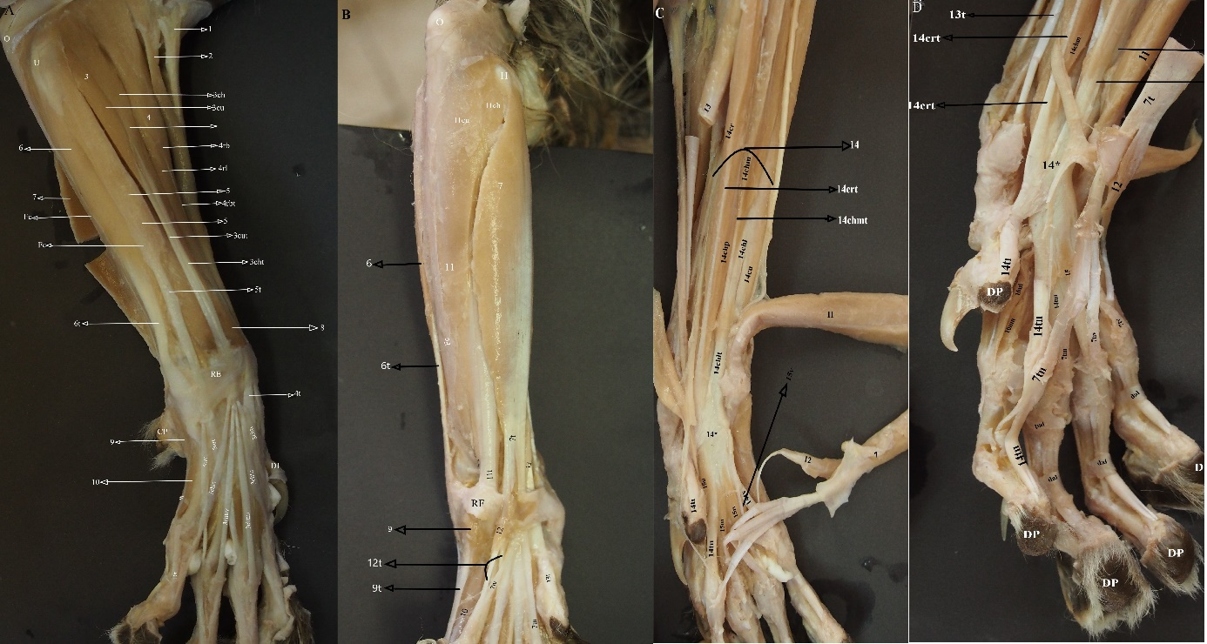
Fig 1: A-The cranial aspect of the antebrachium and manus B- The superficial caudal aspect of the antebrachium and manus C- The deep caudal aspect of the antebrachium and manus D- The deep palmar aspect of the manus

Fig 1: A-The cranial aspect of the antebrachium and manus B- The superficial caudal aspect of the antebrachium and manus C- The deep caudal aspect of the antebrachium and manus D- The deep palmar aspect of the manus
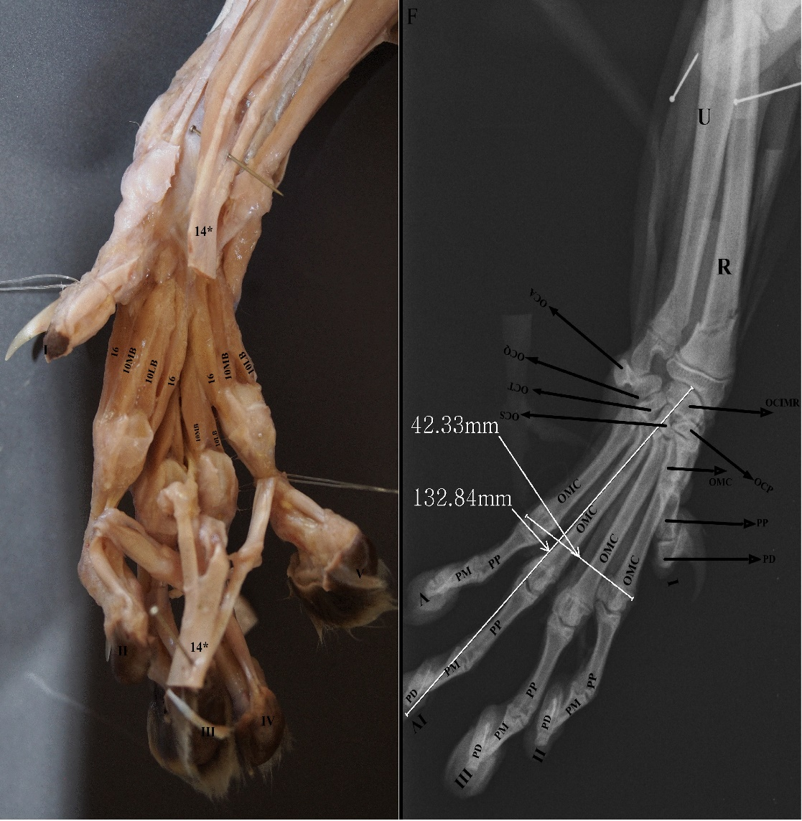
Fig 2: E- The deep palmar aspect of the fingers F- The radiography of the manus
DI. The first finger
O. The olecranon
U. The ulna
I. The first finger
II. The second finger
III. The third finger
IV. The fourth finger
V. The fifth finger
CP. The carpal pad
RF. The retinaculum extensorum
RF. The retinaculum flexorum
MCP. The metacarpal pad
H. The humerus
R. The radial bone
OCA. The accessory carpal bone
OCIM. The intermedioradial bone
OCP. The first carpal bone
OCS. The second carpal bone
OCT. The third carpal bone
OCQ. The fourth carpal bone
OMC. The metacarpal bone
PP. The proximalis phalanx bone
PM. The second phalanx bone
PD. The distal phalanx bone
DP. The digital pad
dal. The distal annular ligament
pal . The proximal annular ligament
Fc. Fascia
- N. musculocutaneus
- The brachioradial muscle
- The common digital extensor muscle (CDEM)
3ch. The humeral head of the CDEM
3cu. The ulnar head of the CDEM
3cht. The humeral head tendon of the CDEM
3cut. The ulnar head tendon of the CDEM
- The radial extensor of the manus (REM)
4rb. The radial extensor brevis of the manus (REBM)
4rbt. The tendon of the REBM
4rl. The radial extensor longus of the manus
- The lateral digital extensor muscle (LDEM)
5t. The tendon of the LDEM
- The ulnar flexor of the manus (UFM)
6t. The tendon of the UFM
- The superficial digital flexor muscle (SDFM)
- The adductor digiti I muscle
- The abductor digiti V muscle (ADVM)
9t. The tendon of the ADVM
- The flexor brevis profundus muscle (FBPM)
10MB. The medial belly of the FBPM
10LB. The lateral belly of the FBPM
10t. The tendon of the FBPM
- The ulnar flexor of the manus (UFM)
11ch. The humeral head of the UFM
11cu. The ulnar head of the UFM
11t. The tendon of the UFM
- The flexor digital brevis manus (FDBM)
- The radial flexor of the manus (RFM)
- The deep digital flexor muscle (DGFM)
14chm. The humeral medial head of the DGFM
14chp. The profound humeral head of the DGFM
14chpt. The profound humeral head tendon of the DGFM
14crt. The radial head of the DGFM
14chl. The lateral humeral head of the DGFM
14cu. The ulnar head of the DGFM
14cut. The ulnar head of the DGFM
- The lumbricalis muscles
- The adductor digital muscles

